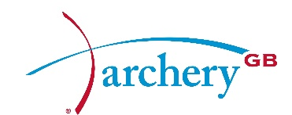

DRAFT BOARD MEETING MINUTES
Thursday 11 March 2016
By Conference Call

Present: | David Harrison | DH | Chairman
 | Neil Armitage | NA | CEO (Interim) & Independent Director
 | Simon Cordingley | SC | Co-opted Director
 | Mark Davies | MD | Independent Director/Chair Elect
 | Muriel Kirkwood | MK | Elected Director & Interim Chair Audit
 | Bob McGonigle | BM | Elected Director & Chair Nominations
 | Bryan Woodcock | BW | Elected Director
In attendance: | David Tillitson (in part) | DT | Performance Director
 | Wendy Stead (in part) | WS | Finance Mananger
Apologies: | Geoff Malyon | GM | Elected Director
 | Alan Willsher | AW | Elected Director
 | Derrick Lovell MBE | DL | President

At 8pm, DH welcomed Board and staff to the meeting specifically convened to consider the Tokyo Para bid submission. NA introduced the item with DT providing detail on the program and WS on the finances. Directors then discussed the bid with the Executive, including:
- The ability to deliver, considering past failures
- The move of coaching delivery into Performance
- The financial risks in shared services caused by the splitting of the Para and Able bodied bids

DH then thanked the staff who left the conference call at this stage. NA proposed the following, with MD seconding.
Resolution: The Board approves the submission of the Tokyo Paralympic Bid

The Board considered the item and then voted to approve.

The Board asked the CEO to ensure:
- Should there be a need to hold a call to approve the Olympic bid, then the date is set as early as possible; and
- An organogram of the Performance Unit (posts, not names) is provided with the Olympic bid paperwork.

At 9pm, DH closed the meeting.

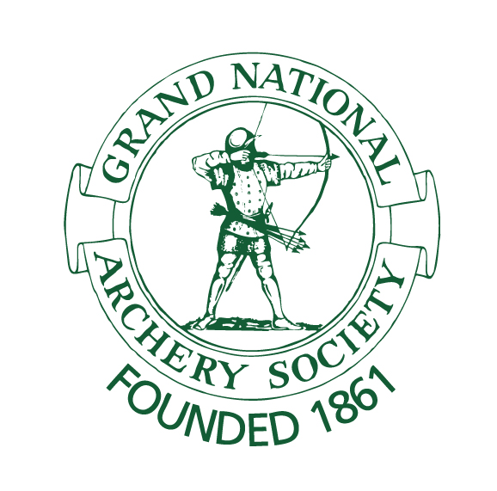 | Archery GB is the trading name of the Grand National Archery Society, a company limited by guarantee no. 1342150 Registered in England.

