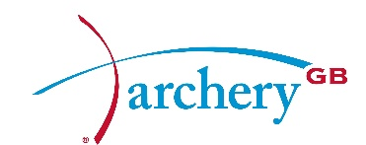

Annual governance statement

Chairman

April 2019

Governance statement April 2019

Introduction from the Chairman, Mark Davies
Good governance is the first requirement of our national governing body (NGB). This is not just because the funding that we get from Government depends on it, but because it embeds in all our structures (and into the sport as a whole) the fairness and transparency which any member may need to use in times of difficulty. It also makes sure that our members can hold us to account (the board are merely the trustees). It also makes sure that the executive, who run the sport, can be held accountable by the board.

Over the past four years our board has changed from being 80% male to having a 50/50 gender split and gone from having no representation for ethnic minorities or people with disabilities to having both. In my view, the board is now significantly better equipped than it has ever been to understand wider viewpoints within the sport, and to be able to take account of the broadest range of views. Among our main aims, we want to encourage new (and ever more diverse) people into the sport and to protect vulnerable people who are already members. Our board is well-placed to fulfil this role effectively.

Every year the board continues to evaluate itself and show improvement, as we can see from the following extract from the board’s effectiveness report.
“This year’s survey would appear to indicate a clear improvement in the functioning of the Board, with general levels of satisfaction and understanding seeming to be higher – in some cases markedly higher – than this time last year.”

Purpose
The purpose of this statement is for us to report to our members and stakeholders (those with an interest in our work) on our performance in terms of governance during the last 12 months.

Archery GB
We are recognised as the NGB for the sport of archery. We are a company limited by guarantee and are registered in England with a company number of 1342150. We are governed by a board of directors.

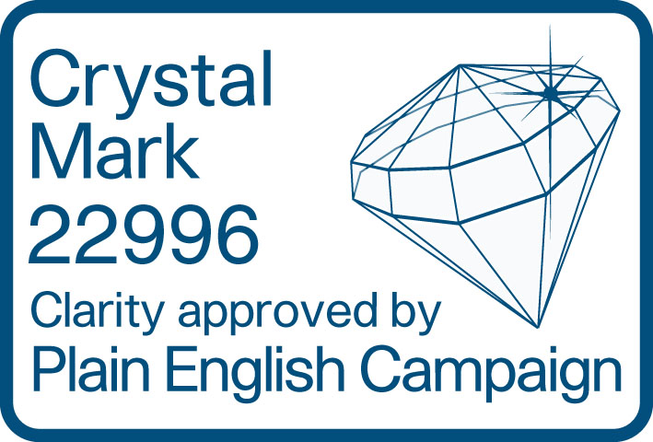

The board
Our board is responsible for setting strategy and overseeing that the executive (the Chief Executive and their team of employees and volunteers) deliver that strategy. The board is made up of:
- an independent chair;
- independent directors; and
- directors who are elected from and by the membership of Archery GB.

The board’s nomination committee oversees director recruitment to make sure that the directors have a wide variety of skills and there is a balance of gender and diversity.

The board also approves and monitors policy and makes sure that risks are properly identified and managed.

The board in 2018
The board continued to meet for half-day meetings six times a year in 2018, in line with the previous year. Two elected directors retired at the AGM in 2018 after completing their terms of service. One director was co-opted, and the board now has 10 people, one of whom is a director due to his position as Chief Executive.

At the 2019 AGM, the Chair will come to the end of his term and will step down. The Senior Independent Director (SID) is also stepping down. Both have been replaced following an extremely thorough recruitment process.

We have kept track of which directors attended board meetings and this is shown below. Additionally, we continue to monitor the costs of running the board

As well as forming committees for audit and risk (chaired by the SID) and nominations (chaired by the Chair), the board has appointed directors specifically to oversee policy areas. As a result, the board has champions for equality, good governance and safeguarding. The board as a whole acts as the Remuneration Committee.

Internal review
The board continues to review itself every year in several ways.
- Directors review the Chair
- The board’s committees review themselves
- The Chair reviews the performance of individual directors
- The board discusses all the above as part of its own review and completes a questionnaire on board performance

External review – The Code for Sports Governance
To continue to receive funding from Sport England and UK Sport, every year we must keep to the Code for Sport Governance that was introduced by the Government in October 2016.

The external audit carried out by UK Sport in 2018 involved 69 tests covering our structure, our people, our communications, our standards and conduct and our policies and procedures. We passed all the 69 tests.

Director and president attendance
Date | CW | DH | ER | JR | LB | LR | MD | MK | NA | PB | ST | TL | YA
25 November 17 | ✓ | X | ✓ | ✓ | ✓ | X | ✓ | ✓ | ✓ | ✓ | ✓ | X
13 January 18 | ✓ | ✓ | ✓ | ✓ | ✓ | ✓ | ✓ | ✓ | ✓ | ✓ | ✓ | ✓
10 March 18 | ✓ | ✓ | X | ✓ | ✓ | ✓ | ✓ | X | ✓ | ✓ | ✓ | ✓
21 April 18 | ✓ | ✓ | ✓ | ✓ | ✓ | ✓ | ✓ | ✓ | ✓ | X | ✓ | ✓
09 June 18 | X |  | ✓ | ✓ | ✓ | ✓ | ✓ |  | ✓ | ✓ | ✓ | X | ✓
21 July 18 | ✓ |  | ✓ | ✓ | ✓ | ✓ | ✓ |  | ✓ | X | ✓ | X | ✓
22 September 18 | ✓ |  | ✓ | ✓ | ✓ | X | ✓ |  | ✓ | X | ✓ | X | ✓

CW – Catherine Wilson DH – David Harrison ER – Erik Rowbotham
JR – Julie Ryan LB – Lis Bellamy LR – Lizzy Rees
MD – Mark Davies MK – Muriel Kirkwood NA – Neil Armitage
PB – Pippa Britton ST – Steve Tully TL – Trish Lovell
YA – Yakoob Ali

Archery GB is the trading name of the Grand National Archery Society, a company limited by guarantee number 1342150 Registered in England.

